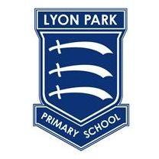
The Wembley Schools Federation
Lyon Park Primary School
Vincent Road, Wembley, Middlesex, HA0 4HH

Executive Headteacher: Mr R Fenton
Headteacher: Ms T Bhambra
Chair of Governors: Mrs I Yarde

Welcome to your new class 4O.
I am Miss Ali and I am excited to have you in my class this year! You are going to have so much fun learning and making new friends. In our class, the eraser is to let you know it’s okay to make mistakes. We’ll correct them and learn from them no matter what it takes!
Now here are a few things about me:
- My favourite colour is blue!
- My favourite food is Watermelon!
- My favourite sport is football!
- My favourite drink is lemon water!
When we start school, I get to know more about you too! Make sure to bring your smile with you and I can’t wait to meet you!
From Miss Ali

Dear Year 4,

My name is Mrs Siyani and I am so excited to be supporting you all next year! Sometimes I have come in year 3 to teach you so I know you all and I am looking forward to seeing you once again in year 4. I'm sure we will learn many things and have lots of fun. During my summer holidays I have discovered how to bake lots of delicious treats in my kitchen - I hope you will all have just as much fun during your summer holiday and I can't wait to meet you and hear all about it.
Mrs Siyani.

