The Wembley Schools Federation
Lyon Park Primary School
Vincent Road, Wembley, Middlesex, HA0 4HH

Executive Headteacher: Mr R Fenton
Headteacher: Ms T Bhambra
Chair of Governors: Mrs I Yarde

Dear RY,
Hello! Welcome to Reception! My name is Ms Farrell and I am very excited to be your new teacher. I have worked at Lyon Park for two years now.
I love swimming, rock climbing, and reading. I also love drama, singing and dancing too. I know we will all have a great time together in Reception. I look forward to getting to know you all and helping you to learn new things whilst having fun.
I hope you have an excellent summer holiday and stay safe.
See you in September!
Best wishes,
Ms Farrell
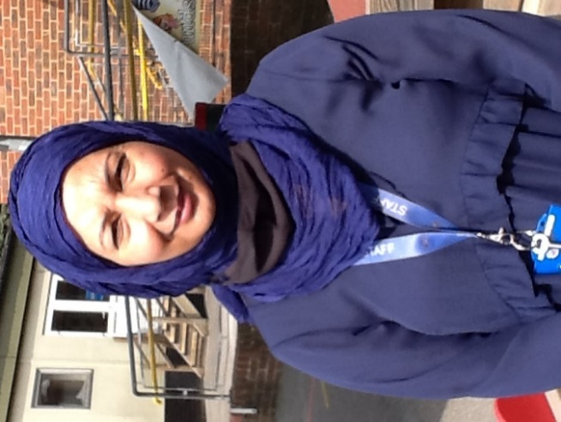

Dear RY
Welcome to your new class. My name is Mrs Shabnam, and I am going to be your new nursery nurse in your class RY this year. I am excited to have you in our class this year and I am sure you are also looking forward to it! You are going to have so much fun learning and making new friends. I cannot wait to meet you all and begin our learning journey together in the new academic year.
From,
Mrs Shabnam

